Heart Dissection. Name___________



1/ Look at the heart from all angles, how many tubes are there going in and out of it? _____________

2/ Hearts are divided into two sides, left and right. Each side is also divided into two parts, the top chamber or atrium and the lower chamber, or ventricle. Without cutting into the heart, try to locate all the chambers.

3/ A-Aorta, B-Vena Cava, C-Right Atrium, D-Pulmonary artery, E-semilunar valve, F-(bicuspid) valve, G-Left Ventricle, H-Cardiac muscle
Bottom of Form
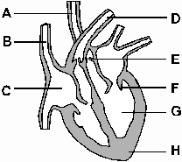

4/ Use a scalpel to carefully cut across the bottom of both the ventricles. Look up and see if you can see the valves between atrium and ventricle.
What is holding the valve together? Describe their appearance.

5/ Open up the right atrium and ventricle (smallest side). On which side of the heart is the heart muscle the thickest? _________________
What is the reason for this? ______________________________________________________________________________________________

6/ The septum is the wall dividing the two ventricles. How thick is it? ______mm

7/What does the inside of the atrium feel like? Is it smooth of wrinkled?
______________________________________________________________________________________________

8/On the outside of the heart are coronary arteries and veins. These bring blood to the heart muscle itself. There will be no blood in these so they will be clear/white. Can you locate them?. ___________
_______________________________________________

